Project Design Phase-II
Data Flow Diagram & User Stories

Date | 08 July 2026
Team ID | Chiranjeevi Chiru, Roshinipriya Elecombadu, Kamakshi Gangarapu, Kavitha Paligala, Kammannagari Kundanasree (Team Lead)
Project Name | StockTrade - MERN Stock Trading Platform (ShopZ E-Commerce)
Maximum Marks | 4 Marks

Data Flow Diagrams:
A Data Flow Diagram (DFD) is a traditional visual representation of the information flows within a system. A neat and clear DFD can depict the right amount of the system requirement graphically. It shows how data enters and leaves the system, what changes the information, and where data is stored.
Example: DFD Level 0 (Industry Standard)
Example: (Simplified)
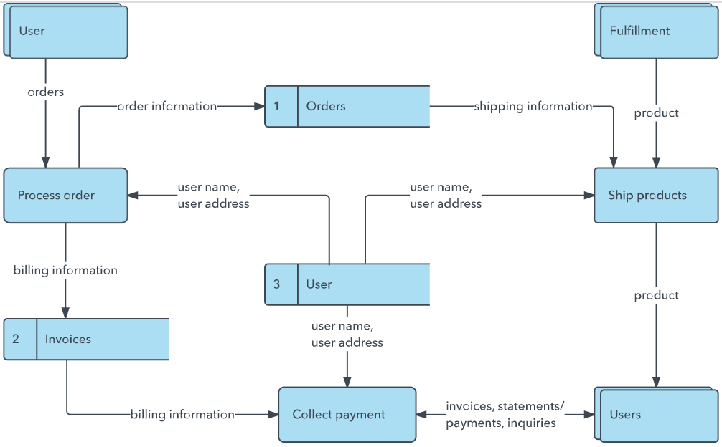


User Stories
Use the below template to list all the user stories for the product.
User Type | Functional Requirement (Epic) | User Story Number | User Story / Task | Acceptance criteria | Priority | Release
Investor (User) | Registration | USN-1 | As a user, I can register by entering my email, password, and confirming my password. | I can access my dashboard after registering | High | Sprint-1
 |  | USN-2 | As a user, my password is securely hashed so my credentials stay protected. | Password is never stored in plain text (bcrypt hash) | High | Sprint-1
 | Login | USN-3 | As a user, I can log in using my email & password to receive a session token. | I receive a valid JWT and am redirected to my dashboard | High | Sprint-1
 | Market Dashboard | USN-4 | As a user, I can view a live-updating list of stocks with current prices. | Prices refresh automatically every 5 seconds | High | Sprint-2
 |  | USN-5 | As a user, I can open a stock's detail page with a live price chart. | Chart updates as new prices arrive | Medium | Sprint-2
Investor (User) | Trading | USN-6 | As a user, I can buy a stock using my virtual cash balance. | Balance decreases and the holding appears in my portfolio | High | Sprint-3
 |  | USN-7 | As a user, I can sell a stock that I own. | Balance increases and the holding is updated/removed | High | Sprint-3
 | Portfolio | USN-8 | As a user, I can view my current holdings with profit/loss. | Profit/loss is shown in value and percentage | High | Sprint-3
 |  | USN-9 | As a user, I can view my past transaction history. | All buy/sell trades are listed with timestamps | Medium | Sprint-3
Administrator | Stock Management | USN-10 | As an admin, I can add or deactivate stock listings. | Stock list updates immediately for all users | High | Sprint-4
 | User Management | USN-11 | As an admin, I can enable or disable user accounts. | Disabled users cannot log in | High | Sprint-4
 | Monitoring | USN-12 | As an admin, I can view all transactions and live trading volume. | Dashboard shows a live transaction feed & stats | Medium | Sprint-4

